Semicustom arrays for the implementation of front-end electronics ICs.
E.V.Atkin¹, A.A.Demin², I.I.Ilyushchenko¹, M.V.Khokhlov², S.V.Kondratenko¹, V.V.Maslennikov¹, Yu.N.Mishin¹, A.D.Pleshko¹, Yu.A.Volkov¹
¹ – MEPhI, Moscow, Russia ² – SRIPEA, Zelenograd, Russia

The approach to designing application specific ICs of front-end electronics on the basis of especially elaborated bipolar semicustom arrays (SA) is grounded. The existing SAs are classified. The structural peculiarities and characteristics of a newly developed bipolar SA, containing complementary transistors, are described.

1.Introduction
During the last several years the volume of data, collected from radiation detectors in the course of large physical experiments, has been constantly increasing. The tasks of front-end electronics have been also expanding – often it should provide not only the preliminary signal processing (including linear conversion and comparison), but also the full data preparation for computer feed-in (analog-digital conversion, multiplexation of several channels). Custom-made ICs, manufactured by CMOS technology, are a class of ICs, promising for the implementation of such front-end electronics. However, a demand on relatively simple ICs, containing (8…16) preliminary processing channels and manufactured by semicustom technology (including bipolar and BiCMOS), does exist and will remain so in future. An essentially lesser cost (at relatively small production volumes) and manufacturing time of semicustom ICs make them an optimal solution in the case, when the detector itself is still in the development stage or is an experimental sample and, consequently, the requirements to front-end electronics are often changed.
The authors of the given paper have been developing during the last 5 years an approach to the design and manufacture of front-end ICs on the basis of especially elaborated analog semicustom arrays (SA). Comparing with the existing general-purpose SAs, the application specific ones allow to implement a greater number of channels, and their contents and structure are chosen with consideration of the convenience to accommodate standard functional units of signal preliminary processing (preamp, shaper, comparator and output stage).

- Classification and characteristics of the existing analog and analog-digital SAs
The existing SAs may be classified into 3 groups, having the following peculiarities in lay-out:
- general purpose – a high degree of lay-out symmetry, non-connected elements;
- functionally oriented – repetition of lay-out of separate functional units or groups of such, partial connection of elements;
- application specific – absence of lay-out symmetry or local symmetry, non-connected elements.
Universal SAs are not intended to implement directly multichannel units and, as a rule, do not allow the manufacture of more than two preliminary processing channels on one chip. In order to raise the integration scale (functional complexity) of semicustom ICs, a part of components in functionally oriented chips are initially interconnected and create standard functional modules (of the op amp kind). The functionally oriented SAs can accept electronic programmation of necessary connections, but the use of standard functional modules does not allow to count on the achievement of the best (for the given technology) operating characteristics of units. If ultimate speed (bandwidth) is necessary, then, due to possible stability problems, one should limit the excess phase shift in feedback circuits and reduce for the sake of that same purpose the values and influences of stray elements by means of optimizing lay-out. The best solution consists in the transition to application specific SAs, wherein any initial interconnection of elements is absent, but their disposition on chip facilitates the simple arrangement of the necessary connections in one-two plating layers for creating ICs of special purpose (for instance multichannel front-end ICs).
Table 1 presents some examples of analog and analog-digital SAs, belonging to different groups. The selection criterion for the data of this table was the active status of the considered SA (presence of its description and advertisement in Internet). Besides that, especial attention was paid to Russian SAs, manufactured by an available for the authors technology, including the earlier manufactured 8-channel bipolar analog application specific SA (ASSA) [2]. The latter, however, contains only npn microwave transistors, what does not allow to use efficient circuital solutions, requiring transistors. Therefore the last design, in which the authors participated, was an analog complementary ASSA, described in the next section.

2.Analog complementary ASSA
The analog complementary ASSA has a quadrant symmetry and contains three analog cells in each quadrant. The structure of an analog cell (see figure below) has some features, making it easy to accommodate in its boundaries the standard stages of functional sections and allowing to improve the performance of those sections [3].
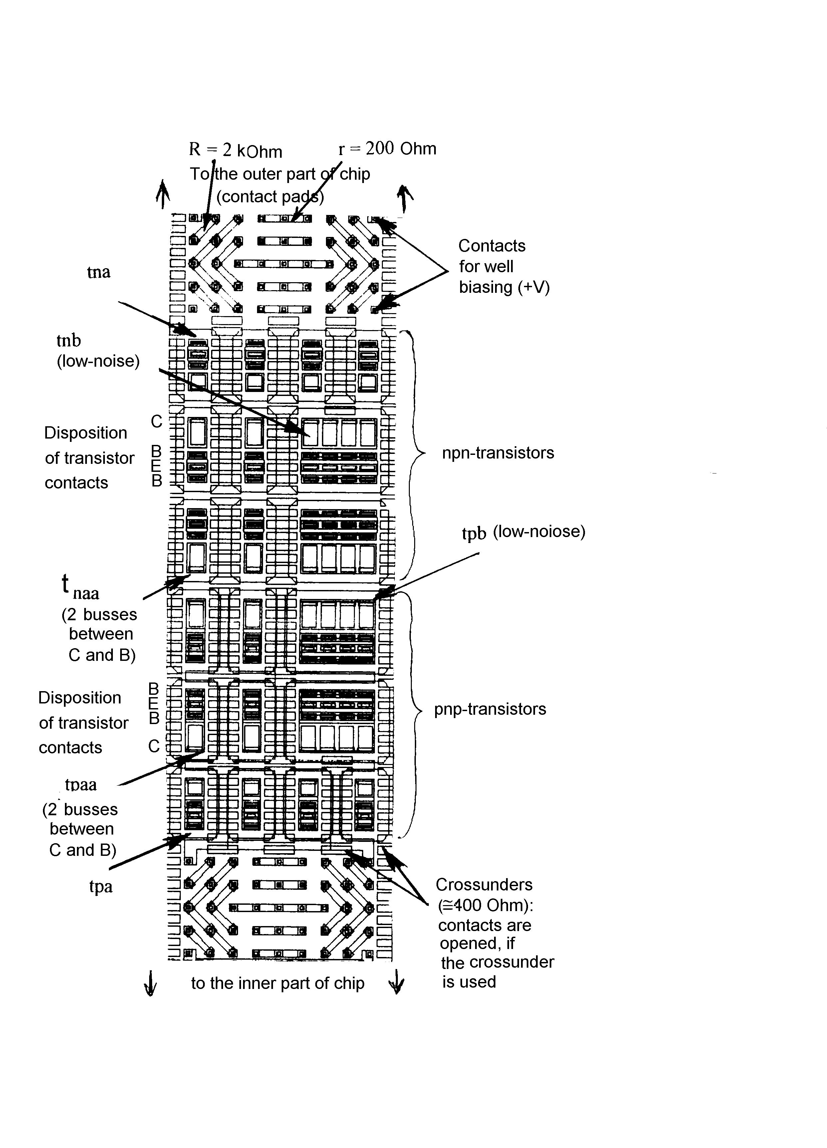
The general quantitative characteristics of the considered ASSA are as follows:
Number of npn-/pnp-transistors in an analog cell | 10/10
Number of resistors with a nominal value 200 Ohm/2 kOhm in an analog cell | 24/32
Number of analog cells | 12
Number of npn- and pnp-transistors on a chip (+number of transistors of increased power type tnh/tph, placed between the contact pads at the chip corners) | 240+8
Number of resistors with nominal values 200 Ohm and 2 kOhm on a chip (+number of resistors with a nominal value 10 kOhm, placed between the contact pads) | 672+32
Number of capacitors with a nominal value 0.5 pF on a chip | 84
Number of contact pads | 24
Chip dimensions, mm | 2.0×2.3

Right from the start of developing the complementary ASSA especial attention was paid to the correct determination (extraction) of the parameters of SPICE-models of its elements. In practice the extraction of some parameters of SPICE-models involves the use of expensive types of measuring equipment (for instance, S-parameter meters), the process of measurement being rather labor-consuming. At high-frequency measurements special measures are required to exclude the influence of stray elements on the results obtained. In this connection at the chip’s first run especial test circuits were placed on it, allowing to simplify the extraction of element SPICE-parameters (first of all – of transistors) at the expense of decreasing the frequencies, whereat the measurements were conducted. Some test circuits allow, moreover, to average the value of the measured parameter simultaneously. The list of test circuits, accommodated on the chip at the first run (excluding separate passive components and transistors), follows:

1 | Operational amplifier with current feedback
2 | Operational amplifier with voltage feedback
3 | Sensor of temperature, version 1
4 | Sensor of temperature, version 2 (with a mutual replacement of npn- and pnp-transistors)
5 | Universal differential complementary stage
6 | Charge-sensitive amplifier
7 | Circuit for the determination of the base resistance of tna transistors
8 | Circuit for the determination of the base resistance of tpa transistors
9 | Circuit for the determination of the parameters TF/CJE of tna transistors
10 | Circuit for the determination of the parameters TF/CJE of tpa transistors
11 | Circuit for the determination of the spread of the emitter-base voltage for tna transistors
12 | Circuit for the determination of the emitter-base capacitance of tna transistors
13 | Circuit for the determination of the base-collector capacitance of tna transistors
14 | Circuit for the determination of the collector-substrate capacitance of tna transistors
15 | Circuit for the determination of the spread of the emitter-base voltage for tpa transistors
16 | Circuit for the determination of the emitter-base capacitance of tpa transistors
17 | Circuit for the determination of the base-collector capacitance of tpa transistors
18 | Circuit for the determination of the collector-substrate capacitance of tpa transistors

Full functional units (circuits 1…6) are intended for a final verification of the models elaborated.
Proceeding from the study of test chips, there was carried out the correction of technology, aimed at improving pnp transistor parameters. On obtaining acceptable results (it is planned to ensure a unity-gain frequency for the smallest by area npn and pnp transistors not less than 4.3GHz and 2.9Ghz correspondingly at a collector current of 1mA) it will become possible to manufacture a larger by area chip, designed to accommodate not less than 8 identical channels.
The manufactured semicustom ICs were used as a basis to create the printed circuit units [4], serving the conduction of physical experiments.

- Conclusion
The tasks, where a relatively small number of analog signal processing channels per package (8…16) is sufficient, but the requirements to those channels may essentially change with time, are advisable to be solved by use of analog semicustom arrays. The use of the existing general application and functionally oriented analog SAs does not always allow to ensure the required characteristics of semicustom ICs and accommodate more than two channels per package. The pointed out disadvantages can be overcome at the expense of specializing the SA to suit the design of semicustom ICs of special application (including front-end ICs). However the choice of application specific analog SAs at present is not high. The application specific analog complementary SA developed will allow to extend the capabilities of designers.

References:
- Development of an 8-channel PCB for minidrift chamber / E.Atkin, Yu.Volkov, I.Ilyushchenko and oth. // Proceedings of the First Workshop on Electronics for LHC Experiments. – Lisbon, September 11-15, 1995. – P.127-129.
- An application specific semicustom array for the implementation of multichannel front-end ICs. / A.Arkhangelsky, E.Atkin, S.Kondratenko and oth. // Proceedings of the Third Workshop on Electronics for LHC Experiments. – London, September 22-26, 1997. – P.466-470.
- Analog semicustom array for the implementation of wide-band amplifiers. / Volkov Yu., Demin A., Mishin Yu. and oth. // Proceedings of the LVI scientific session of the Popov Science and Technology Society on Radioengineering and Electric Communication, May 2001, Moscow. – P.208-210.
- Multichannel printed circuit units for collecting detector signals. / Chernikov V., Subbotin V., Volkov Yu., Mishin Yu. // Published in the same proceedings.

