IC of a low-dispersion timing discriminator, intended to process nanosecond pulses.

Authors: Savelyev D.I., Zhukov V.S., Khlopkov P.V.
Moscow Engineering Physics Institute, department of Electronics.
115409, Moscow, Kashirskoe shosse, 31.
zhukov@eldep.mephi.ru

Introduction.
Timing discriminators are the basic elements of timing channels. Such discriminators convert the input signals to the standard logic pulses, exactly corresponding to the moment of event occurrence. The noise in the input signals and different rise-times of input pulse result in fluctuations of the time point, when the output signal appears. This limits the accuracy of defining the moment, when the event occurs. Besides, the own restrictions of timing discriminators, like inherent noise and finite charge sensitivity, influence essentially the accuracy. The IC of a timing discriminator with optimized time parameters, built on an analog semicustom array, is described in this article.

Structural diagram of timing discriminator.

Fig. 1 shows the structural diagram of a timing discriminator. In the course of designing the given circuit the experience of designing similar devices was used [2, 3, 4].
The low-dispersion comparator, working in a constant fraction mode (LDCFC – low-dispersion constant fraction comparator), is the main part of the timing discriminator.
The 3-bit DAC has been included in the structure of timing discriminator to compensate the offset voltage of comparator with low dispersion of propagation delay.
The output logic type switcher allows choosing the ECL or GTL output signal logic.
The micropower comparator, working with fixed threshold (LEMC – leading edge micropower comparator), has been included in the timing channel to reduce noise and disturbance influence on the
From delay line
From attenuator
External
capacitor
Input
signal
Threshold
External
capacitor
External
capacitor
+
-
+
-
LDCFC
LEMC
Input signal
Outputs
Additional
delay
Repeated
switching
preventer
Output
drivers
Event choosing
circuit
Threshold
voltage
filter
Comparator
active mode
biaser
Comparator
sensitivity
correction
circuit
Propagation
delay
correction
circuit
Input
signal
splitter

DAC
3
DAC control
inputs
Logic
type
switcher
Output
logic
type
3

Fig.1. Structural diagram of timing discriminator.

timing channel. The input signal is applied to the first input of micropower comparator and the threshold voltage is applied to the second one. Its output signal permits the work of an event choosing device (ECD). So, noises and disturbances do not affect the output signal of the whole timing channel.
Biasing the comparator to the linear segment of switching curve allows us to increase its gain and permits operation with input signals of very small amplitude. Further such a biasing will be mentioned as the comparator active mode. To do this biasing the active mode biaser has been included in the structure.

Peculiarities of LDCFC.

Minimization of propagation delay dispersion for different amplitudes of input pulses is the dominating problem. This minimization has been attained by using the methods of non-linear signal processing. The main idea is to make the comparator transfer function Uout (Uin) more linear. Non-linear characteristics of transistors in each input differential stage are compensated by other non-linearities.
The differential circuit with non-linear dynamic loads was used to minimize the dispersion of propagation delay. The current amplification method instead of the voltage amplification one has been implemented by means of differential two stage current cells. The main task of the optimization process is the trade-off between the increase of gain and the decrease of dispersion of propagation delay. The usually used approach is to minimize the absolute propagation delay. The lesser is the propagation delay the lesser becomes its despersion. Our aproach is different. Usage of non-linear methods allows minimizing dispersion of propagation delay without any minimization of the absolute propagation delay.
LDCFC test results.
Basic comparator experimental characteristics:
- Offset voltage within ± 2 mV,
- Input current less than 10 μA,
- DC gain more than 500,
- Dynamic gain more than 2000,
- Power consumption less than 200 mW,
- Power supply ± 5 V.

Test equipment: oscilloscope Tektronix TDS 3054, input pulse source Я4C-89.
Dependences of propagation delay on input overvoltage for the typical (1) and designed (2) comparators at zero offset voltage are shown in fig. 2.
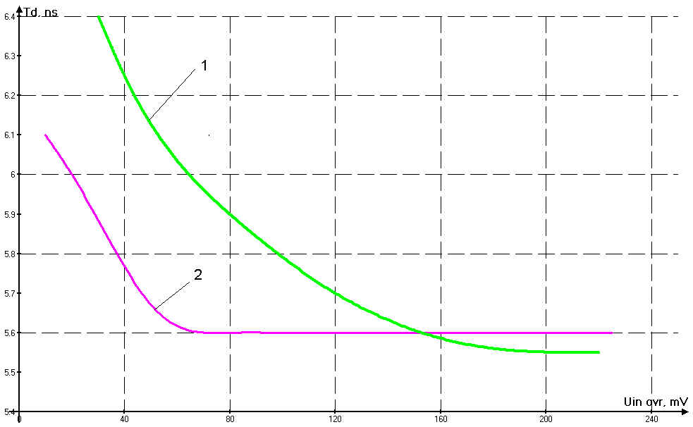The curves show, that the input signals dynamic range of the designed comparator is essentially widened towards the low amplitude region, comparing with the typical comparator at the same dispersion of
Fig. 2. Propagation delay vs input overvoltage.
propagation delay. This fact allows reducing the power consumption of the timing channel. That is topical for physical experiments with a large number of detector channels.

Conclusion.

The article presents our last results in the development of low-dispersion timing comparators. Further all the elements of structural diagram (fig. 1) will be manufactured on one chip.

References.
1. Atkin E.V., Demin A.A., Ilyushchenko I.I., KhoKhlov M.V., Kondratenko S.V., Maslennikov V.V., Mishin Yu.N., Pleshko A.D., Volkov Yu.A. “Semicustom arrays for implementation of front-end electronics ICs”. Report at the current conference.
2. Atkin E., Khlopkov P., Volkov Yu. “A discriminator PCB for precise timing signal generation”, Proceedings of the Third Workshop on Electronics for LHC Experiments, London, September, 1997, pp. 497-499.
3. Jochmann Michael W. “A CMOS Integrated Timing Discriminator Circuit for Fast Scintillation Counters”, IEEE Transaction on nuclear science, Vol. 45, No. 3, June 1998, pp. 740-744.
4. Atkin E., Ilyushchenko I, Khlopkov P., Kondratenko S., Kuprianov E., Mishin Yu., Pleshko A., Savelyev D., Volkov Yu., Zhukov V. “Discriminator ICs for tracking and time-of-flight detectors”, Proceedings of the Forth Workshop on Electronics for LHC Experiments, Rome, September, 1998, pp. 550-554.

