PCI INTERFACE FOR THE KK009/KK012 CAMAC - CONTROLLERS

Yu.B. Semenov, V.E. Zhuchko, D.V. Kamanin

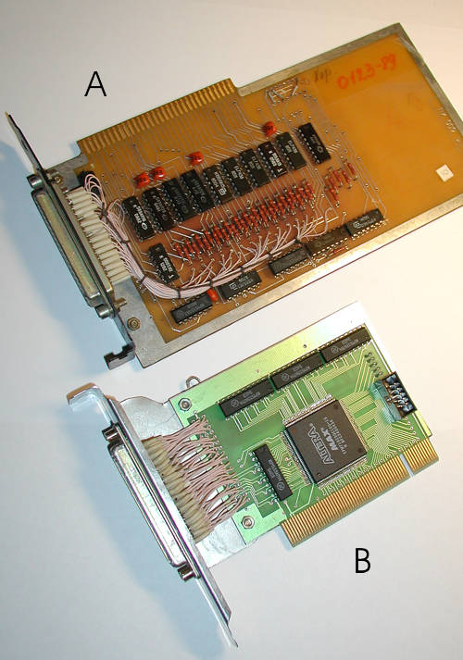Fig.1
More than 10 years ago the CAMAC crate controllers KK009-KK012 were developed in the JINR¹⁾. These controllers can be connected to the IBM PC/XT/AT using appropriate ISA interface cards PK009-PK012 (see A on the Fig. 1).
But recent PC’s motherboards have only fast PCI slots and ISA standard now is obsolete. For this reason the new universal PCI interface card has been developed in the FLNR (see B on the Fig. 1)). This card can be used with the KK009-KK012 crate controllers instead of old PK009-PK012 ISA interfaces which allow building up of the data acquisition systems on the base of the modern PC. This card is based on the programming logic microchip ALTERA type EP1K50QC208-3 of the ACEX series. Moreover, it facilitates the systematical upgrade of the system and applications of available software solutions, permitting to change the hardware configuration of this interface card accordingly to the special end-user requests.
This card provides Plug and Play possibilities; upon the start of PC the BIOS POST will assign automatically the appropriate available base address and free IRQ number. These settings can be read from the PCI configuration space, under condition of using ones in the program configurations this card is fully compatible with the old sofware written for the PK009-PK012. At the same time, new PCI interface card provides the fastest execution of the CAMAC functions, 1.7μs instead of 4-6μs for the PK009-PK012. Connection cable between the new PCI interface card and CAMAC controllers has the same arrangement as for the PK009-PK012 and can be used without any changes.
The area of using of this PCI card is very wide and includes all manufactured in the JINR KK009/KK012 CAMAC controllers (about 4000).

REFERENCES

- Antyukhov V. A. et al. Digital CAMAC Modules (Issue XV), P10-87-928, JINR, 1987.

